COMPOUND INTEREST AND DEPRICIATION
Pearson Edexcel - Tuesday 11 June 2019 - Paper 3 (Calculator) Foundation Tier

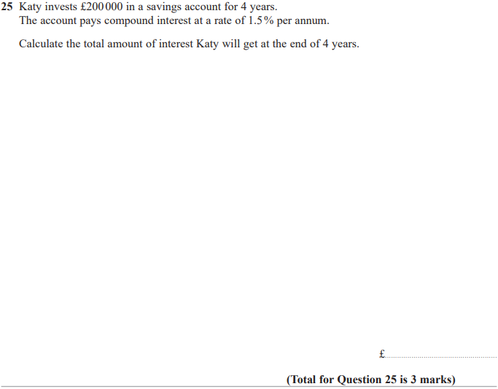

Pearson Edexcel - Thursday 8 November 2018 - Paper 2 (Calculator) Foundation Tier

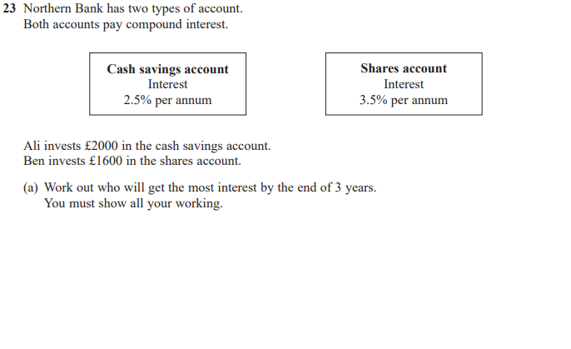
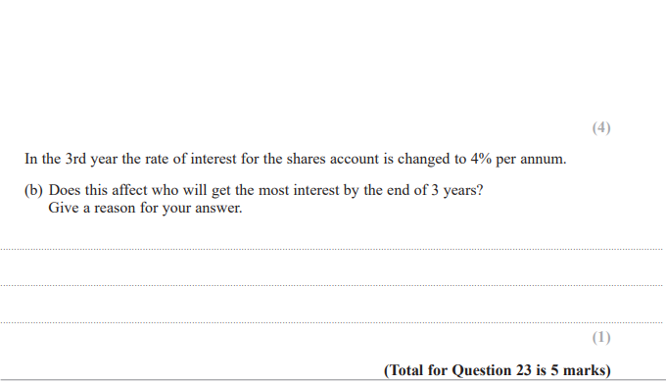

Pearson Edexcel – Specimen 2 - Paper 2 (Calculator) Foundation Tier

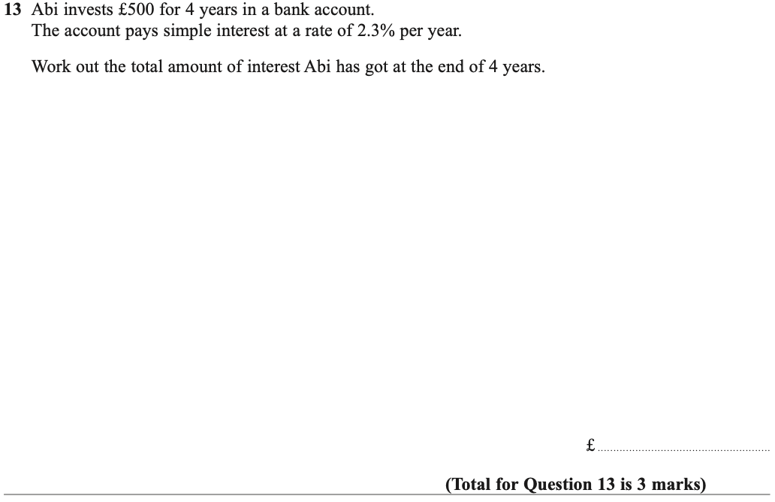

Pearson Edexcel – Specimen 1 - Paper 2 (Calculator) Foundation Tier

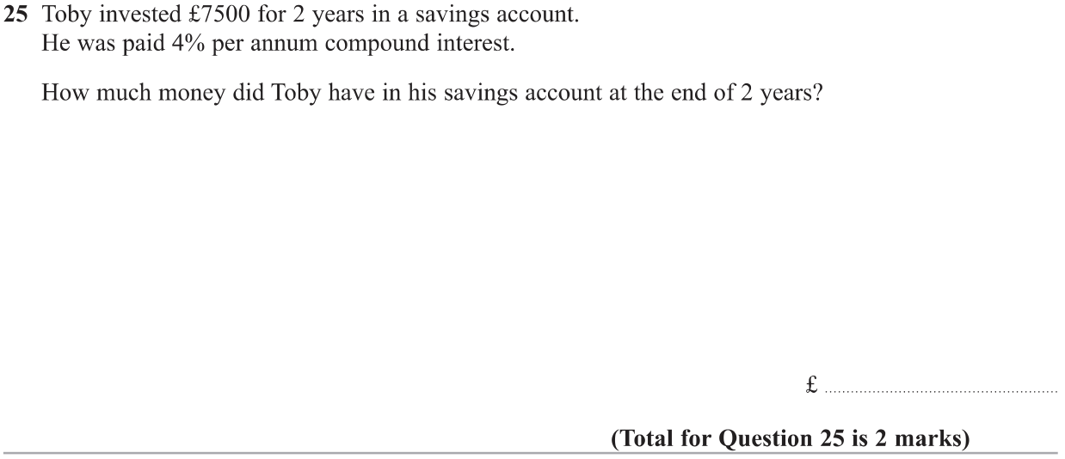

OCR Thursday 05 November 2020- Morning (Non-Calculator) Foundation Tier
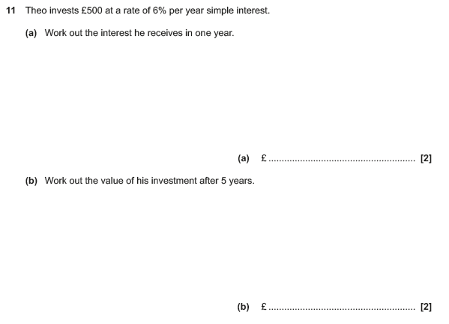

OCR Monday 11 November 2019 – Afternoon (Calculator) Foundation Tier

OCR Tuesday 21 May 2019 – Morning (Calculator) Foundation Tier
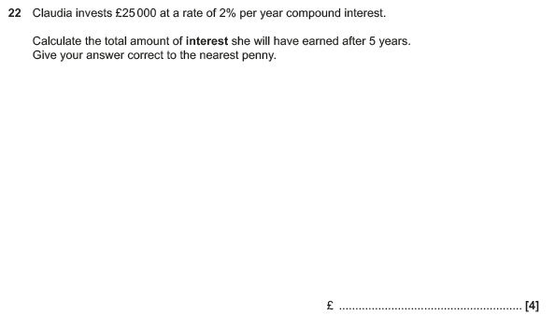

OCR Tuesday 6 November 2018 – Morning (Calculator) Foundation Tier
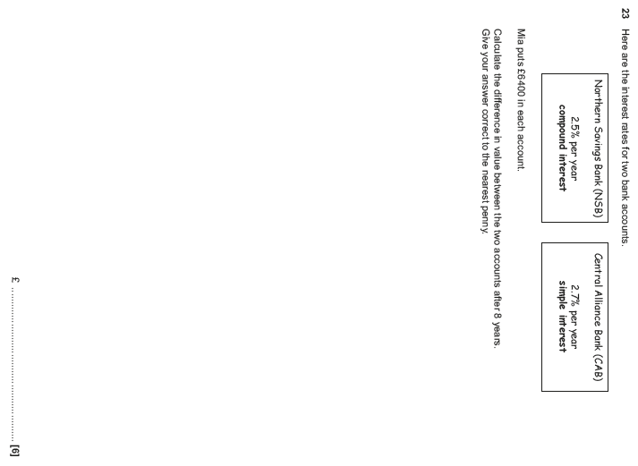

OCR Wednesday 8 November 2017– Morning (Calculator) Foundation Tier

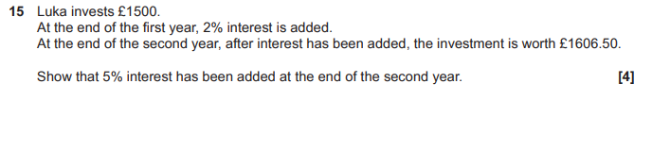
OCR Thursday 25 May 2017 – Morning (Calculator) Foundation Tier

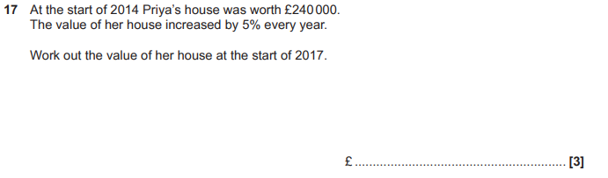

OCR Tuesday 13 June 2017 – Morning (Calculator) Foundation Tier

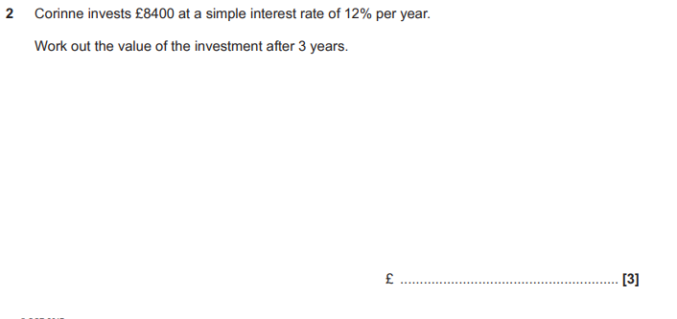

OCR Sample Question Paper 3 – Morning/Afternoon (Calculator) Foundation Tier

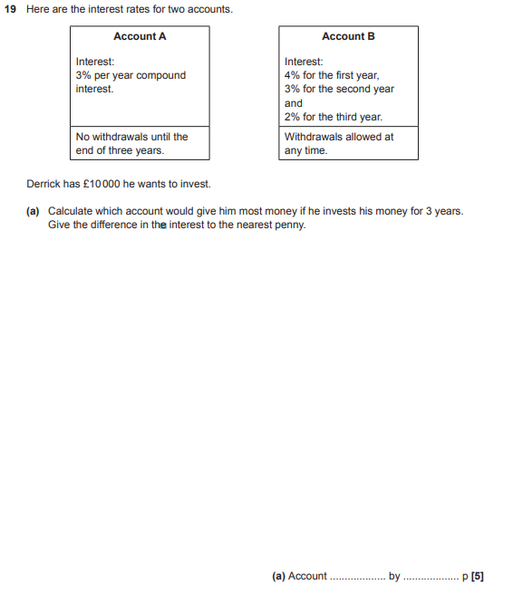

AQA Thursday 11 June 2019 – Morning (Calculator) Foundation Tier

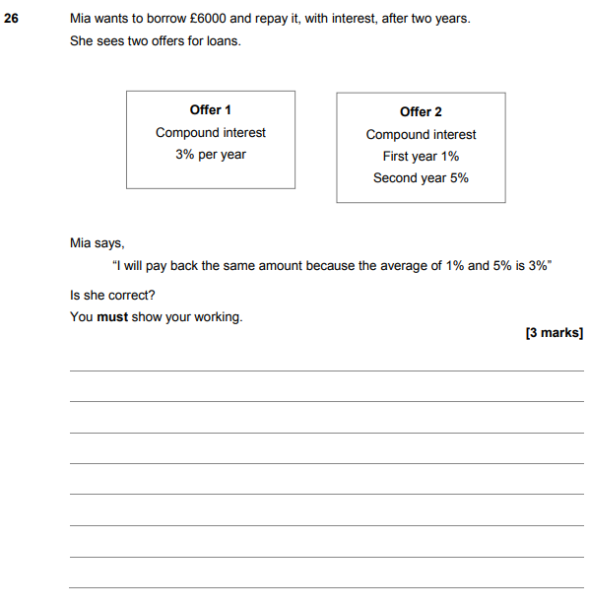

AQA Tuesday 12 June 2018 – Morning (Calculator) Foundation Tier

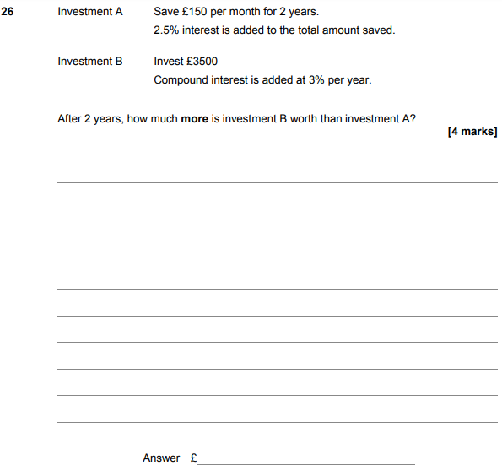

AQA Wednesday 8 November 2017 – Morning (Calculator) Foundation Tier

